Geometric Chuck

Choosing this option on the main menu allows you to choose one of the many patterns discussed in Thomas Bazley's [1] book.

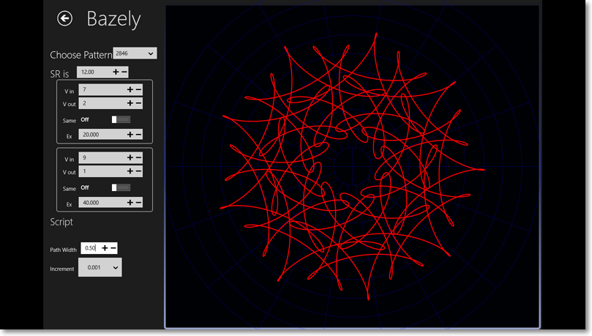
Above you see an image of the Bazley page showing pattern #2846 there are 3453 patterns described altogether. This covers most of the figures in Bazley’s book that can be generated by a single run of the chuck. A run of the chuck is one where all the adjustments are constant. However several patterns in his book are the result of multiple runs with adjustments in between so these patterns are not reproduced accurately (at present) by this software.
You choose the pattern from the Choose Pattern Combo box at the top of the page and the values of the chuck settings are displayed underneath. These settings can be adjusted and the path display is updated to reflect this. You can export these new values to your disc if you want to keep them.
You can also inspect the values of the points along the path by right clicking to see the bottom App bar and then clicking on the points button.


This will cause the points inspector flyout to appear
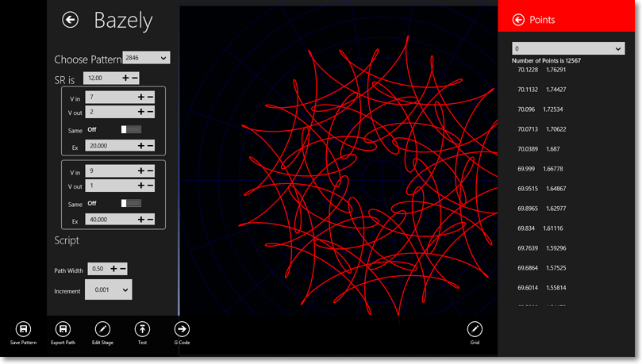
The scale of the drawing is defined in relation to the grid shown in blue. The scale is set so that the grid just fills the drawing area. You can of course adjust the grid by clicking the edit grid button located at the right hand side of the bottom App bar.

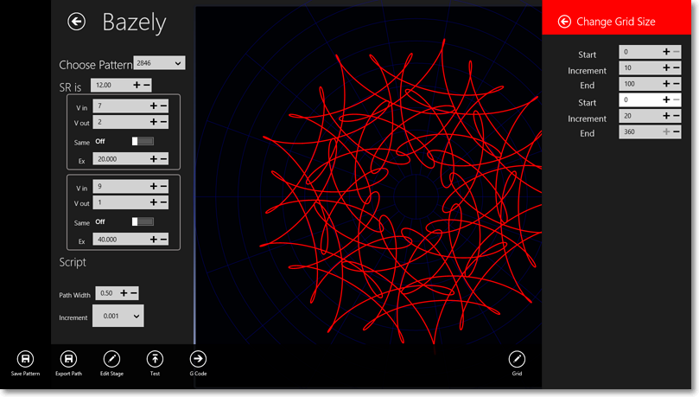
The top range is the Radial range for the grid, whilst the second range is the angular range in both cases the increment gives the distance between successive markings on the grid.

